Calculus-2
Instructor: Fareeha Sultan

FAST-NUCES
Karachi Campus

Assignment-3
Due on: Mid 2 of Cal-II

Submission instructions: This assignment should be done individually. Make sure that student name and I.D. are listed on the submission. If you receive help from someone outside your study group, excluding the course staff, you must also acknowledge them on your assignment.

Polar Curves
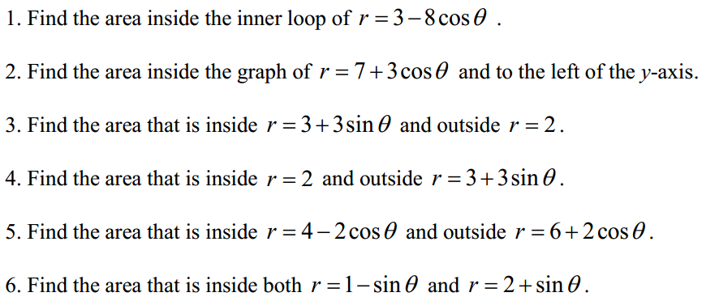
Dot and Cross Products
For problems 6 and 7 find the area of the parallelogram that has u and v as adjacent sides.
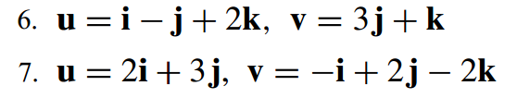
For problems 8 and 9 find the area of the triangle with vertices P, Q, and R.
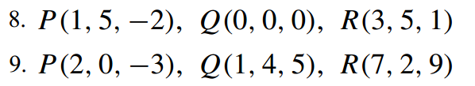
For problems 12 and 13 use a scalar triple product to find the volume of the parallelepiped that has u, v, and w as adjacent edges.
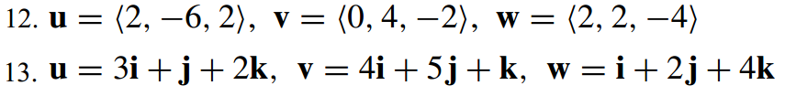
14. In each part, use a scalar triple product to determine whether the vectors lie in the same plane.
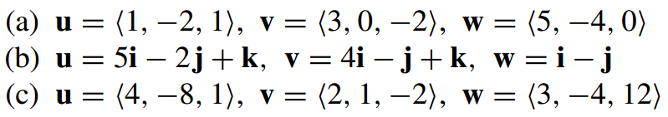
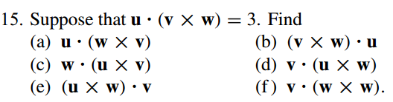
Equations of Lines
For problems 1 – 4 give the equation of the line in vector form, parametric form and symmetric form.
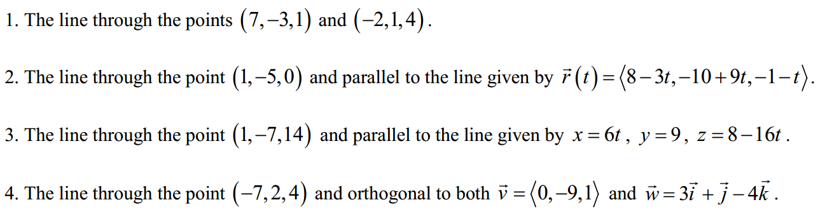
For problems 5–7 determine if the two lines are parallel, orthogonal or neither.
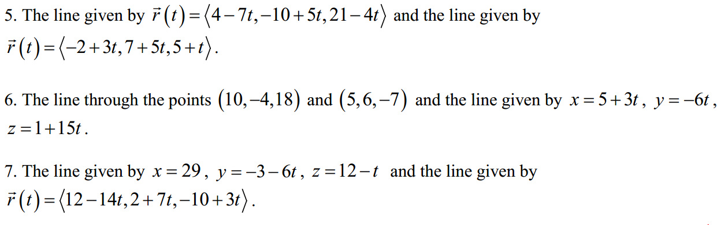For problems 8 – 10 determine the intersection point of the two lines or show that they do not intersect.
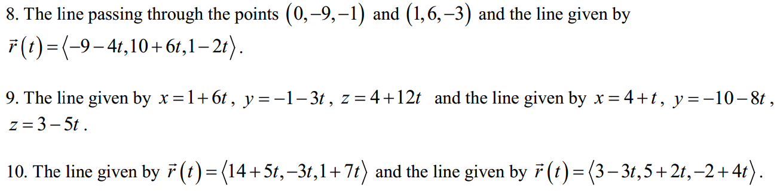
For problems 11 and 12 show that the lines L₁ and L₂ are parallel.
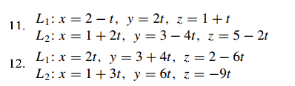
Equations of Planes
For problems 1 – 5 write down the equation of the plane.
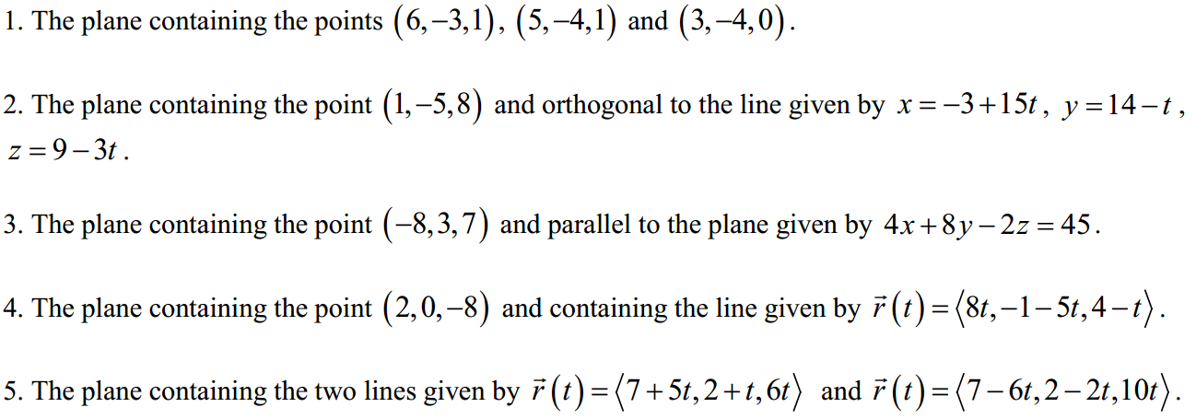
For problems 6 – 8 determine if the two planes are parallel, orthogonal or neither.
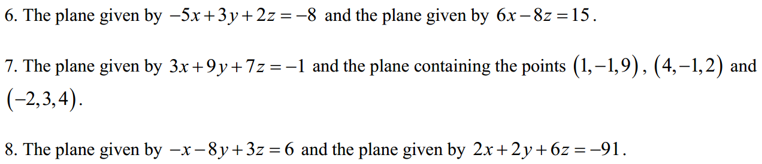
For problems 9 – 11 determine where the line intersects the plane or show that it does not intersect the plane.
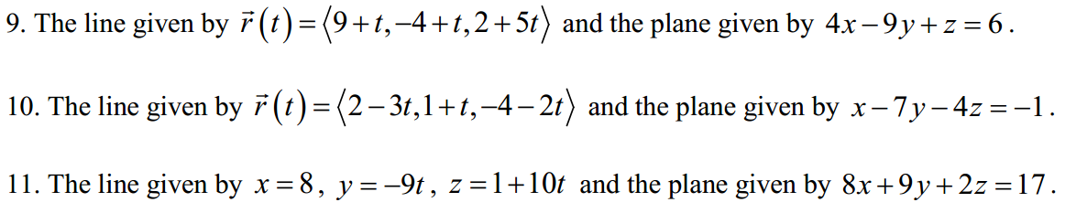
Partial Derivatives
13.3. Q (1-14, 25-52, 81-92)
13.5. Q (1-10, 17-34)
13.6. Q (1-25, 33-46)
Complex Numbers
